**PATUAKHALI SCIENCE &**

**TECHNOLOGY UNIVERSITY**



**Course Code:** CIT-112 CSE 19th Batch 2021-2022

**Assignment No:** **Basic Code-08**

# Assignment Topic: Function and Pointer + W3 resources- Function, Pointer, Recursion

**SUBMITTED TO:**

Prof. Md Mahbubur Rahman

Faculty of Computer Science & Engineering

Department of Computer & Information Technology

**SUBMITTED BY:**

**Name: ABUL BASAR**

**ID:2102036; Registration No: 10163**

Faculty of Computer Science and Engineering

**Date of submission:18 August 2023**

**1.Problem exchange two number for using pointer function:**

#include<stdio.h>

void exchange (int *a, int*b)

{

int tem;

tem=*a;

*a=*b;

*b=tem;

printf("%d %d",*a,*b);

}

int main()

{

int x,y;

scanf("%d%d",&x,&y);

exchange(&x,&y);

}

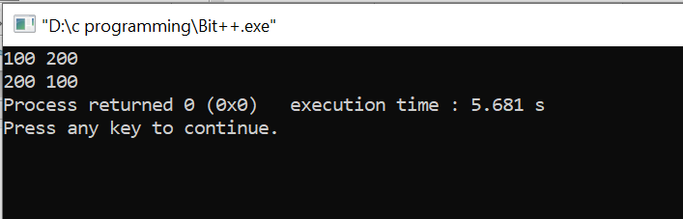

**2.Problem pointer W3:-4 Write a program in C to add two numbers using pointers.**

#include<stdio.h>

void sum(int *x,int *y)

{

int sum=*x+*y;

printf("The sum of the entered numbers is :%d\n",sum);

}

int main()

{

int a,b;

scanf("%d%d",&a,&b);

sum(&a,&b);

}

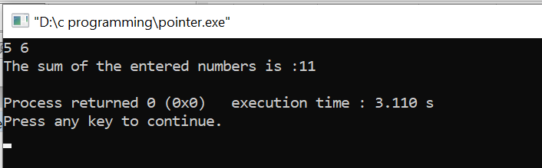

**3.Problem pointer W3:-6Write a program in C to find the maximum number between two numbers using a pointer.**

#include<stdio.h>

void sum(int *x,int *y)

{

if(*x>*y)

printf("%d is the maximum number.",*x);

else

printf("%d is the maximum number.",*y);

}

int main()

{

int a,b;

scanf("%d%d",&a,&b);

sum(&a,&b);

}

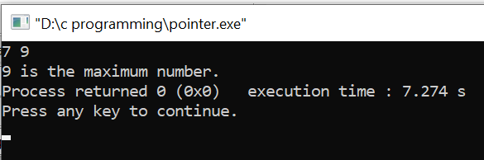

**4.Problem W3:-7 Write a program in C to store n elements in an array and print the elements using a pointer.**

#include<stdio.h>

int main()

{

int a[5];

int *parr[5];

for(int i=0;i<5;i++)

{

printf("element -%d:",i);

scanf("%d",&a[i]);

}

printf("OUTPUT:\n");

for(int i=0;i<5;i++)

{

parr[i]=&a[i];

}

for(int i=0;i<5;i++)

{

printf("element -%d:%d\n",i,*parr[i]);

}

}

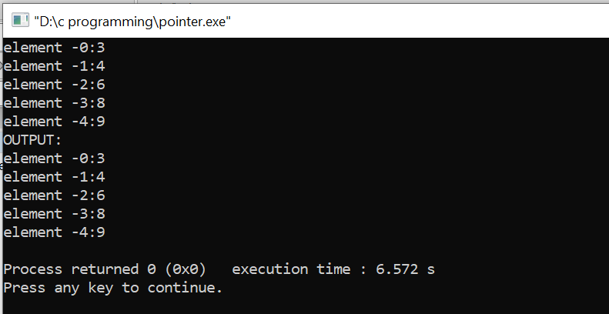

**5.Problem W3 Pointer:-11 Write a program in C to swap elements using call by reference.**

#include<stdio.h>

void sup(int *a,int *b,int *c)

{

printf("The value before swapping are : \n");

printf("element 1:%d\nelement 2:%d\nelement 3:%d\n",*a,*b,*c);

int temp;

temp=*c;

*c=*b;

*b=temp;

temp=*a;

*a=*b;

*b=temp;

printf("The value After swapping are : \n");

printf("element 1:%d\nelement 2:%d\nelement 3:%d",*a,*b,*c);

}

int main()

{

int x,y,z;

printf("elements:\n");

scanf("%d%d%d",&x,&y,&z);

sup(&x,&y,&z);

}

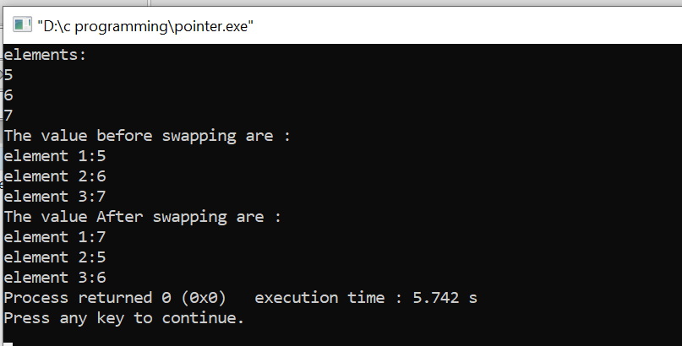

**6.Problem W3 resource pointer:-12 Write a program in C to find the factorial of a given number using pointers.**

#include<stdio.h>

void f(int *a)

{

int fact=1;

for(int i=1;i<=*a;i++)

{

fact=fact*i;

}

printf("\nThe Factorial of %d is :%d\n",*a,fact);

}

int main()

{

int n;

printf("Input a number :");

scanf("%d",&n);

f(&n);

}

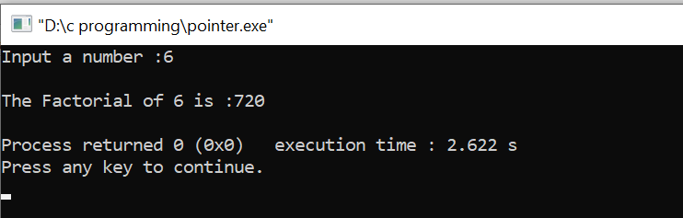

**07.Write a function exchange to interchange the values of two variables, say x and y. Illustrate the use of this function, in a calling function. Assume that x and y are defined as global variables.**

**Ans:**

#include<stdio.h>

int x,y;

void exchange(){

int c=x;

x=y;

y=c;

}

int main(){

x=10;

y=20;

printf("%d\n%d\n",x,y);

exchange();

printf("%d\n%d\n",x,y);

return 0;

}

**Output:**

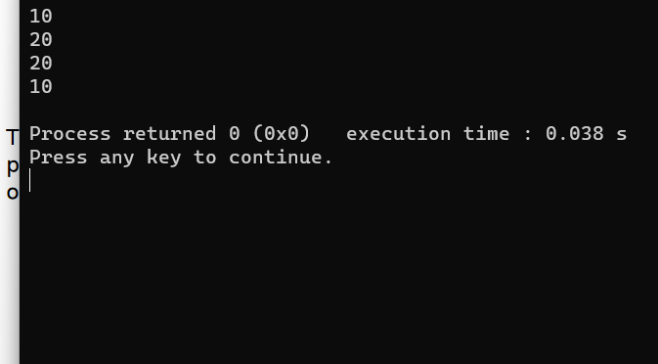

**8. Write a function space(x) that can be used to provide a space of x positions**

**between two output numbers. Demonstrate its application**.

**Ans:**

#include<stdio.h>

int main()

{

int x=2,y=3;

printf("%d\n",x);

dinar();

printf("%d\n",y);

return 0;

}

void dinar()

{

printf(" ");

}

**Output:**

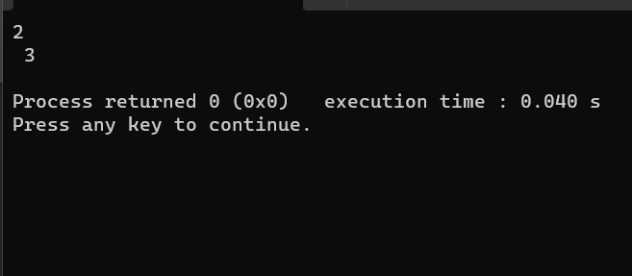

**9. Use recursive function calls to evaluate**

**Ans:**

#include<stdio.h>

#include<math.h>

double fact(int power)

{

double f=1;

if(power==1)

return 1;

else

f=power*fact(power-1);

return f;

}

int main()

{

int i=1;

double x,term,deno,lob,sin,power=3;

scanf("%lf",&x);

term=x;

sin=x;

while(term>=0.0001)

{

lob=pow(x,power);

deno=fact(power);

term=lob/deno;

power+=2;

if(i%2==1)

sin-=term;

else

sin+=term;

i++;

}

printf("%lf",sin);

return 0;

}

**Output:**

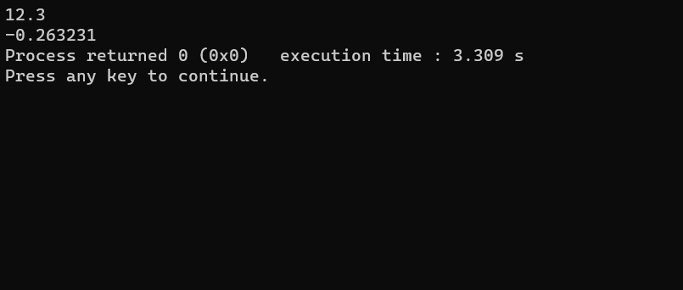

**10. An n_order polynomial can be evaluated as follows: P=(….((a0x+a1)x+a2)x+a3)x+…+an)**

**Ans:**

#include<stdio.h>

#include<conio.h>

typedef struct poly

{

int coeff;

int expo;

}p;

p p1[10],p2[10],p3[10];

void main()

{

int t1,t2,t3,k;

int read(p p1[10]);

int add(p p1[10],p p2[10],int t1,int t2,p p3[10]);

void print(p p2[10],int t2);

void printo(p pp[10],int t2);

t1=read(p1);

print(p1,t1);

t2=read(p2);

print(p2,t2);

t3=add(p1,p2,t1,t2,p3);

printo(p3,t3);

getch();

}

int read(p p[10])

{

int t1,i;

printf("\n Enter the total no of terms");

scanf("%d",&t1);

printf("\n Enter the coeff and expo in descending order");

for(i=0;i<t1;i++)

scanf("%d%d",&p[i].coeff,&p[i].expo);

return(t1);

}

int add(p p1[10],p p2[10],int t1,int t2,p p3[10])

{

int i,j,k;

int t3;

i=0,j=0,k=0;

while(i<t1 && j<t2)

{

if(p1[i].expo==p2[j].expo)

{

p3[k].coeff=p1[i].coeff+p2[j].coeff;

p3[k].expo=p1[i].expo;

i++;j++;k++;

}

else if(p1[1].expo>p2[j].expo)

{

p3[k].coeff=p1[i].coeff;

p3[k].expo=p1[i].expo;

i++;k++;

}

else

{

p3[k].coeff=p2[j].coeff;

p3[k].expo=p2[j].expo;

j++;k++;

}

}

while(i<t1)

{

p3[k].coeff=p1[i].coeff;

p3[k].expo=p1[i].expo;

i++;k++;

}

while(j<t2)

{

p3[k].coeff=p2[j].coeff;

p3[k].expo=p2[j].expo;

j++;k++;

}

t3=k;

return(t3);

}

void print(p pp[10],int term)

{

int k;

printf("\n\n Given Polynomial:");

for(k=0;k<term-1;k++)

printf("%dx^%d+",pp[k].coeff,pp[k].expo);

printf("%dx^%d",pp[k].coeff,pp[k].expo);

}

void printo(p pp[10],int term)

{

int k;

printf("\n\n The addition of polynomial:");

for(k=0;k<term-1;k++)

printf("%dx^%d+",pp[k].coeff,pp[k].expo);

printf("%dx^%d",pp[k].coeff,pp[k].expo);

}

**Output:**

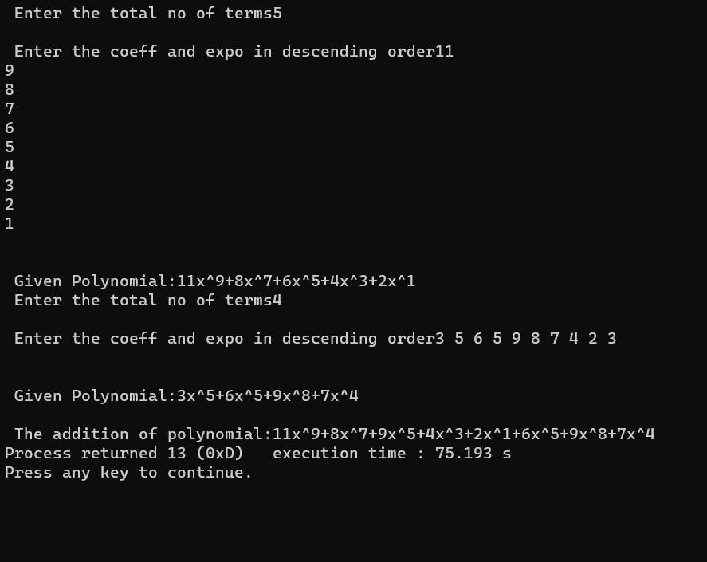

**11. Write afuntion to evaluate the polynomial ,using an array variable.Test it using a main program.**

**The Fibpnacci numbers are defined recursively as follows: F1=1 F2=1 Fn=Fn-1+Fn-2,n>2 Write a function that will generate and print the first n Fibanacci numbers . Test the function for N=5,10,and 15**

**Ans:**

#include<stdio.h>

#include<conio.h>

Int fib(int  i);

Void main()

{  int F[10];F[0]=0,F[1]=1;

Int fib(int  i)

{  for(i=2;i<10;++i)

F[i]=F[i-2]+F[i-1];

for(i=0;i<10;++i)

printf(“%d\n”,F[i]);

fib(i);

}return(fib);

getch(); }

**Output:**

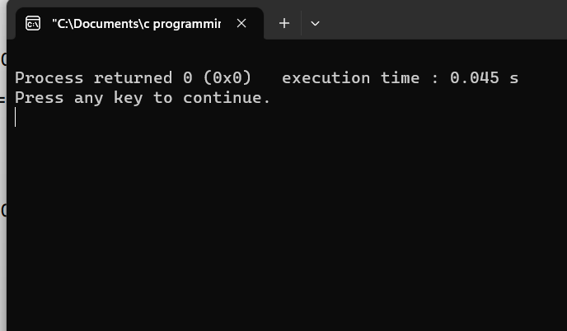

**12. Write a function that will round a floating-point number to an indicated decimal place. For example the number 17.457 would yield the value 17.46 when it is rounded off to two decimal places.**

**Ans:**

#include<stdio.h>

#include<string.h>

#include<stdlib.h>

void liton(void);

void main()

{

liton();

getch();

}

void liton(void)

{

char d[100];

float f;

int l,i;

gets(d);

l=strlen(d);

for(i=0;i<l;i++)

{

if(d[i]=='.')

{

if(d[i+2]>=5)

{

d[i+2]++;

d[i+3]="";

break;}

}

}

f=atof(d);

printf("%.2f",f);

}

**Output:**

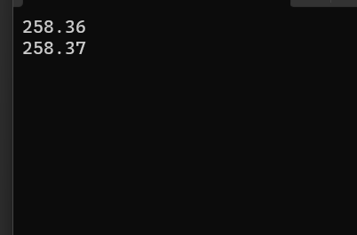

**13. Write a function prime that returns 1 if its argument is a prime number and returns zero otherwise.**

**Ans:**

#include<stdio.h>

int main()

{

int v;

v=sum(5,6);

printf("%d\n",v);

return 0;

}

int sum(int i, int j)

{

int total=i+j;

return(total);

}

**Output:**

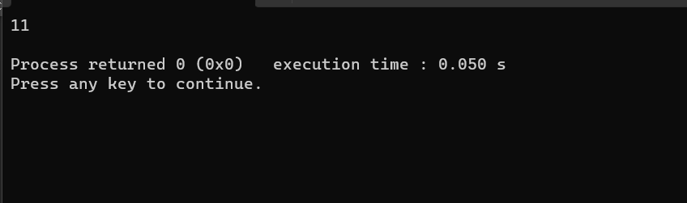

**14: Develop a top_down modular program to implement a calculator. The program should request the user to input two numbers and display one of the following as per the desire of the user:**

**(a) Sum of the numbers**

**(b) Difference of the numbers**

**(c) Product of the numbers**

**(d) Division of the numbers**

**Ans:**

#include<stdio.h>

void diff (int I,int j) ;

void main()

{

diff(5,6);

getch();

}

void diff(int i, int j)

{

int total;

total=i-j;

printf("%d",total);

}

**Output:**

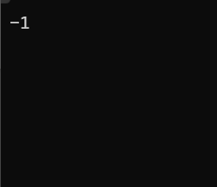

**15. Division of the numbers Provide separate functions for performing various tasks such as reading, calculating and displaying. Calculating module should call second level modules to perform the individual mathematical operations. The main function should have only function calls.**

**Ans:**

#include<stdio.h>

float di(float i,float j)

{

float total=i/j;

return(total);

}

int main()

{

float v;

v=di(5.0,6.0);

printf("%f\n",v);

return 0;

}

**Output:**

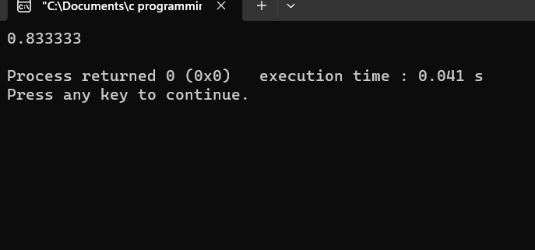

**16. Develop a modular interactive program using functions that reads the values of three sides of a triangle and displays either its area or its perimeter as per the request of the user. Given the three sides a, b and c.**

**Ans:**

#include<stdio.h>

float area(int a,int b,int c)

{

int s=perimeter(a,b,c);

float A; A=sqrt((s-a)*(s-b)*(s-c));

return(A);

}

int main()

{

int a,b,c;

float r;

printf("input a,b,c\n");

scanf("%d %d %d",&a,&b,&c);

r=area(a,b,c);

printf("%f\n",r);

return 0;

}

int perimeter(int a,int b,int c)

{

int s; s=(a+b+c)/2;

return(s);

}

**Output:**

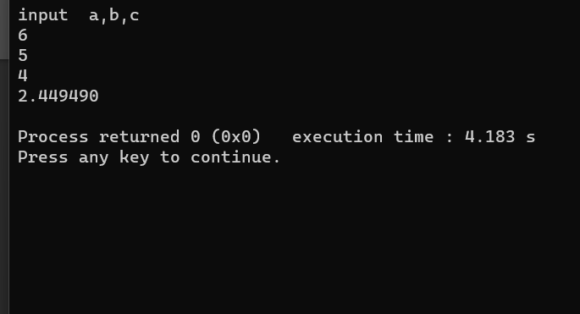

**17. Write a function that can be called to find the largest element of an m by n matrix.**

**Ans:**

#include<stdio.h>

#include<conio.h>

void max_ele(int r,int c,int dinar[][11]);

void main()

{

int sazon[11][11]={0},k;

int r,c,i,j;

printf("Enter nomber of rows and columns(Maximun number can be 11):");

scanf("%d%d",&r,&c);

printf("Enter the elements of the matrix in rowwise:\n");

for(i=0;i<r;i++)

for(j=0;j<c;j++)

{

scanf("%d",&k);

sazon[i][j]=k;

}

max_ele(r,c,sazon);

getch();

}

void max_ele(int r,int c,int sazon[][11])

{

int max,i,j;

max=sazon[0][0];

for(i=0;i<r;i++)

for(j=0;j<c;j++)

{

if(max<sazon[i][j])

{

max=sazon[i][j];

}

}

printf("\nThe maximum elements is:%d",max);

}

**Output:**

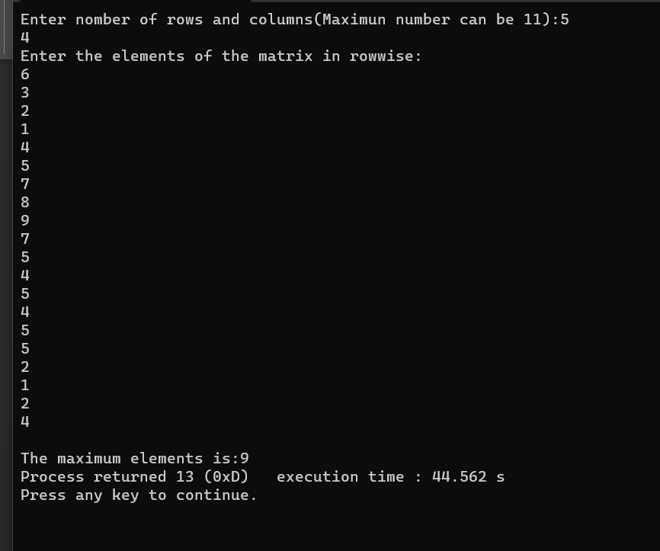

**18. Reverse a sentence using recursion function.**

**Ans:**

#include<stdio.h>

int main()

{

printf("Enter a sentence:\n");

reversesentence();

return 0;

}

void reversesentence()

{

char c;

scanf("%c",&c);

if(c != '\n')

{

reversesentence();

printf("%c",c);

}

}

**Output:**

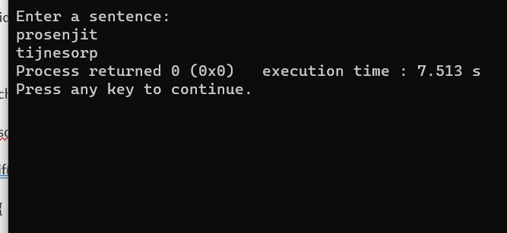

**19.Recursion function for sum of natural numbers.**

**Ans:**

#include<stdio.h>

int main()

{

int number ,result;

printf("Enter a positive number:\n");

scanf("%d",&number);

result=sum(number);

printf("sum= %d\n",result);

return 0;

}

int sum(int x)

{

if(x!=0)

return x+sum(x-1);

else

return x;

}

**Output:**

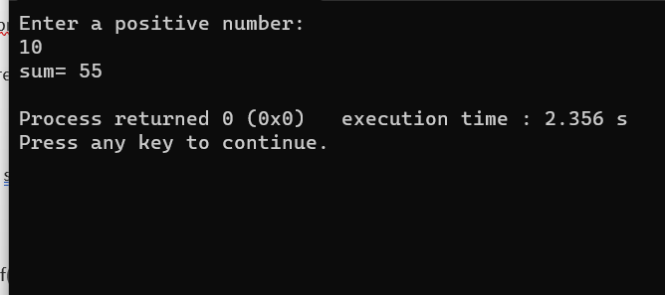

**20.Find factorial of a number using recursion function**

**Ans:**

#include<stdio.h>

int main()

{

int n;

printf("Enter poitive integer:\n");

scanf("%d",&n);

printf("Factorial of %d = %d\n",n,multiplynumber(n));

return 0;

}

int multiplynumber(int n)

{

if(n>=1)

{

return n*multiplynumber(n-1);

}

else{

return 1;

}

}

**Output:**

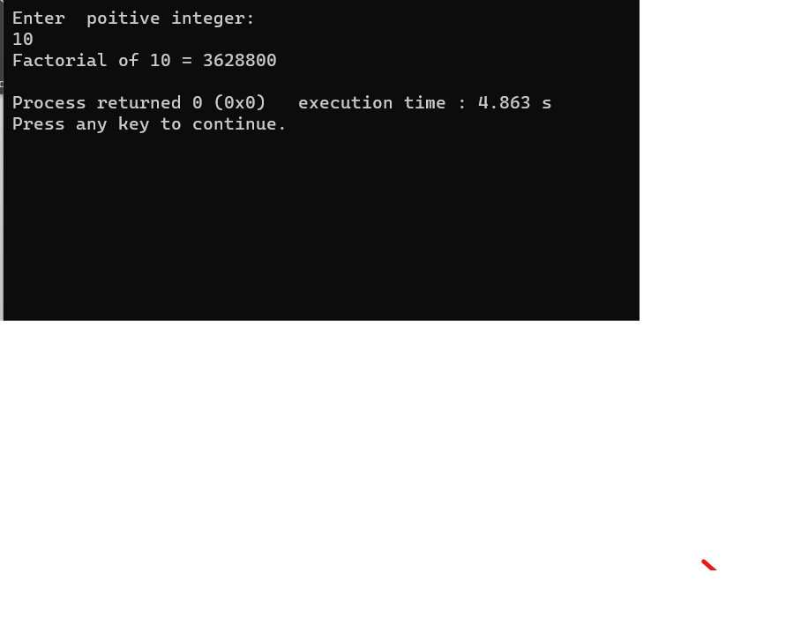

**21. Find the maximum number between two number by using pointer.**

**Ans:**

#include<stdio.h>

int main()

{

int n,m,*p1=&n,*p2=&m;

printf("Enter the first number:\n");

scanf("%d",p1);

printf("Enter the second number:\n");

scanf("%d",p2);

if(*p1>*p2)

printf("\n\n%d is the maximum number.",*p1);

else

printf("\n\n%d is the maximum number.",*p2);

return 0;

}

**Output:**

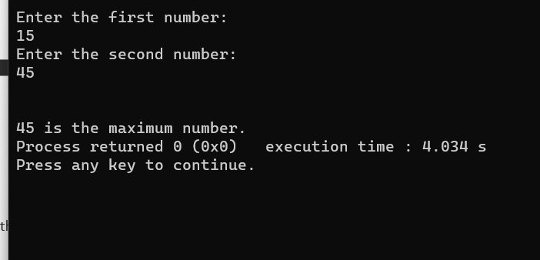

**22. Store and retrieve element from an array by using pointer.**

**Ans:**

#include<stdio.h>

int main()

{

int a[50],i,n;

printf("Enter the number of element of store in the array:\n");

scanf("%d",&n);

printf("Input %d number of element in the array:\n",n);

for(i=0;i<n;i++)

{

printf("element -%d:",i);

scanf("%d",a+i);

}

for(i=0;i<n;i++)

{

printf("The element you entered-%d : %d\n",i,*(a+i));

}

return 0;

}

**Output:**

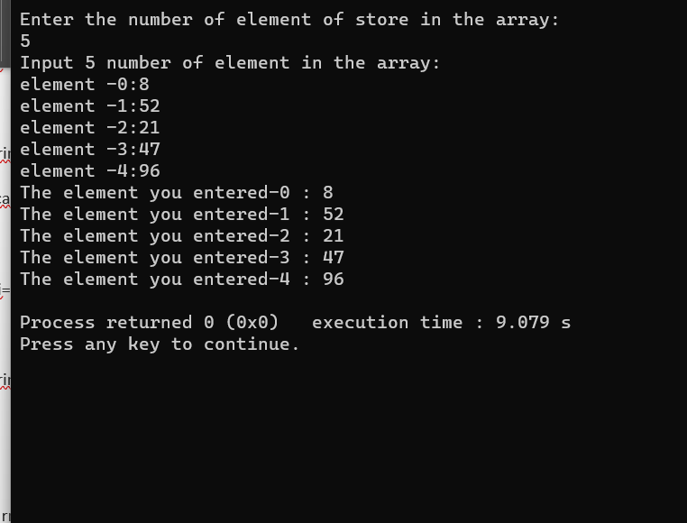

**23. Calculate the length of string by using pointer.**

**Ans:**

#include<stdio.h>

int main()

{

char s[100];

int i;

printf("Enter a string:\n");

gets(s);

i=calculatelength(s);

printf("The length f the string: %d\n",i);

return 0;

}

int calculatelength(char* ch)

{

int c=0;

while(*ch !='\0')

{

c++;

ch++;

}

return c;

}

**Output:**

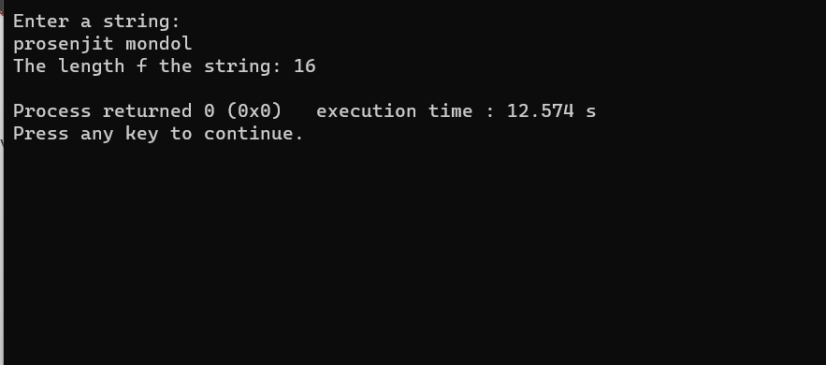

**24. Find the factorial of a given number by using pointer.**

**Ans:**

#include<stdio.h>

int main()

{

int fact,num;

printf("Enter a number :\n");

scanf("%d",&num);

findfact(num,&fact);

printf("The factorial of %d is : %d",num,fact);

return 0;

}

int findfact(int n,int *f)

{

int i;

*f=1;

for(i=1;i<=n;i++)

*f=*f*i;

return *f;

}

**Output:**

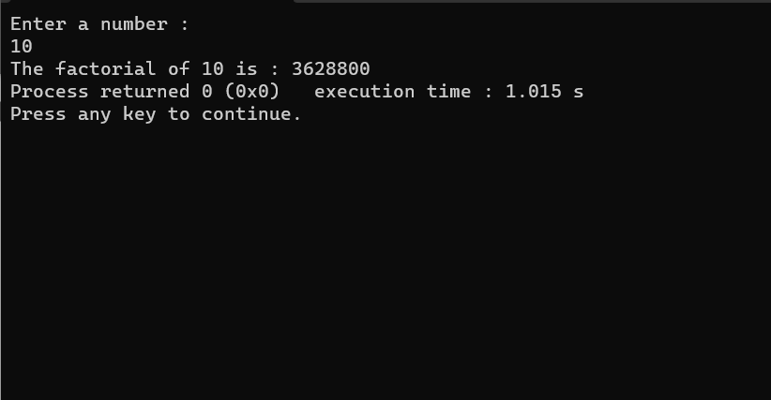

**25. Sort an array using pointer.**

**Ans:**

#include<stdio.h>

int main()

{

int *a,i,j,temp,n;

printf("Enter the number of element to store in the array:\n");

scanf("%d",&n);

printf("Enter the element:\n");

for(i=0;i<n;i++)

scanf("%d",a+i);

for(i=0;i<n;i++)

{

for(j=i+1;j<n;j++)

{

if(*(a+i)>*(a+j))

{

temp=*(a+i);

*(a+i)=*(a+j);

*(a+j)=temp;

}

}

}

printf("The element in the array after sorting:\n");

for(i=0;i<n;i++)

{

printf("%d :- %d\n",i+1,*(a+i));

}

return 0;

}

**Output:**

